SBN repeated message issue

SBN will retransmit messages back to the sender processor. Logic to inhibit it seems to have been removed over the years. See Figure

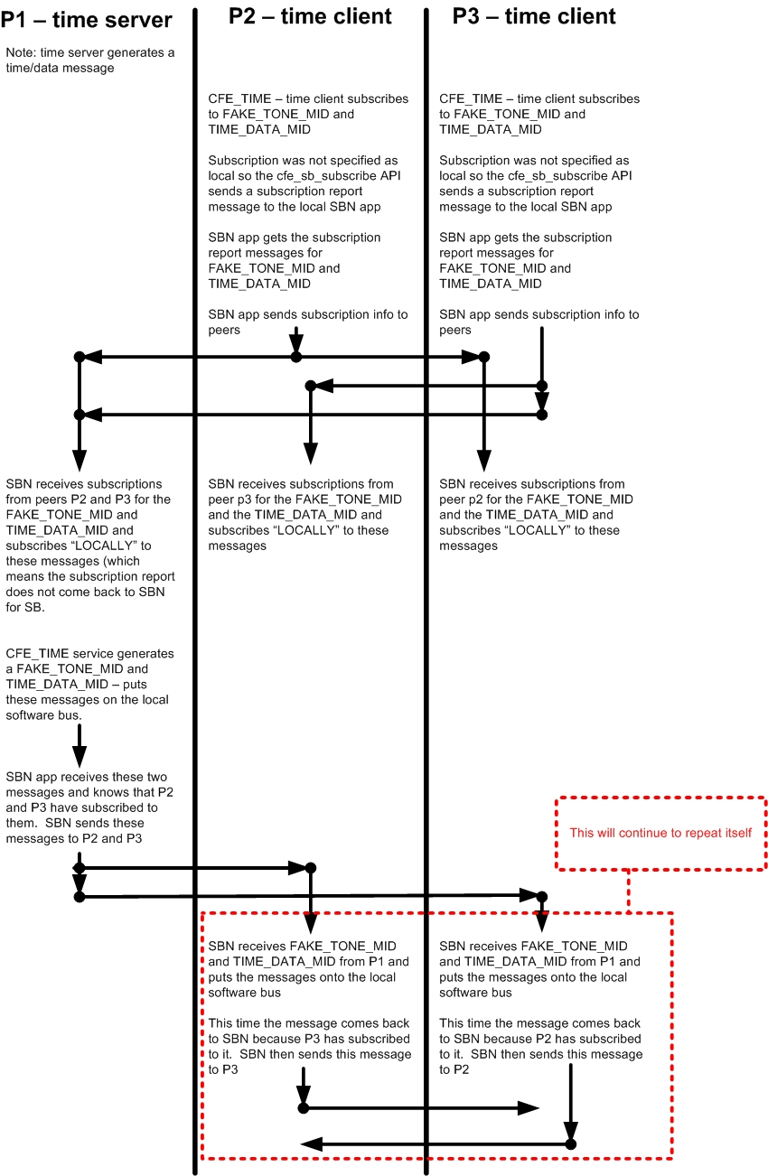

Solution is to restore SBN logic to only transmit on the network interface packets where the sender CPU ID is not equal to the destination CPU ID. (i.e. don’t send it back to the sender) The information is in the CFE_SB_SenderId_t data structure.

CPU 1 -> CPU2 -> CPU3 where CPU 3 subscribes to CPU 1 data.



int32 **SBN_SendNetMsg**(uint32 MsgType, uint32 MsgSize, uint32 PeerIdx)